**Kinesis 101**

**What is streaming data?**

* It is data that is generated continuously by thousands of data sources, which typically send in the data records simultaneously, and in small sizes (order of Kilobytes).
  + Purchases from online stores.
  + Stock prices
  + Game data (as the game plays)
  + Social network data
  + Geospatial data (think of a GPS or uber)
  + IOT sensor data

**What is Kinesis?**

* It is a platform on AWS to send your streaming data to. Kinesis makes it easy to load and analyze streaming data, and also providing the ability for you to build your own custom applications for your business needs.

**The core Kinesis Services:**

* Kinesis Streams  
  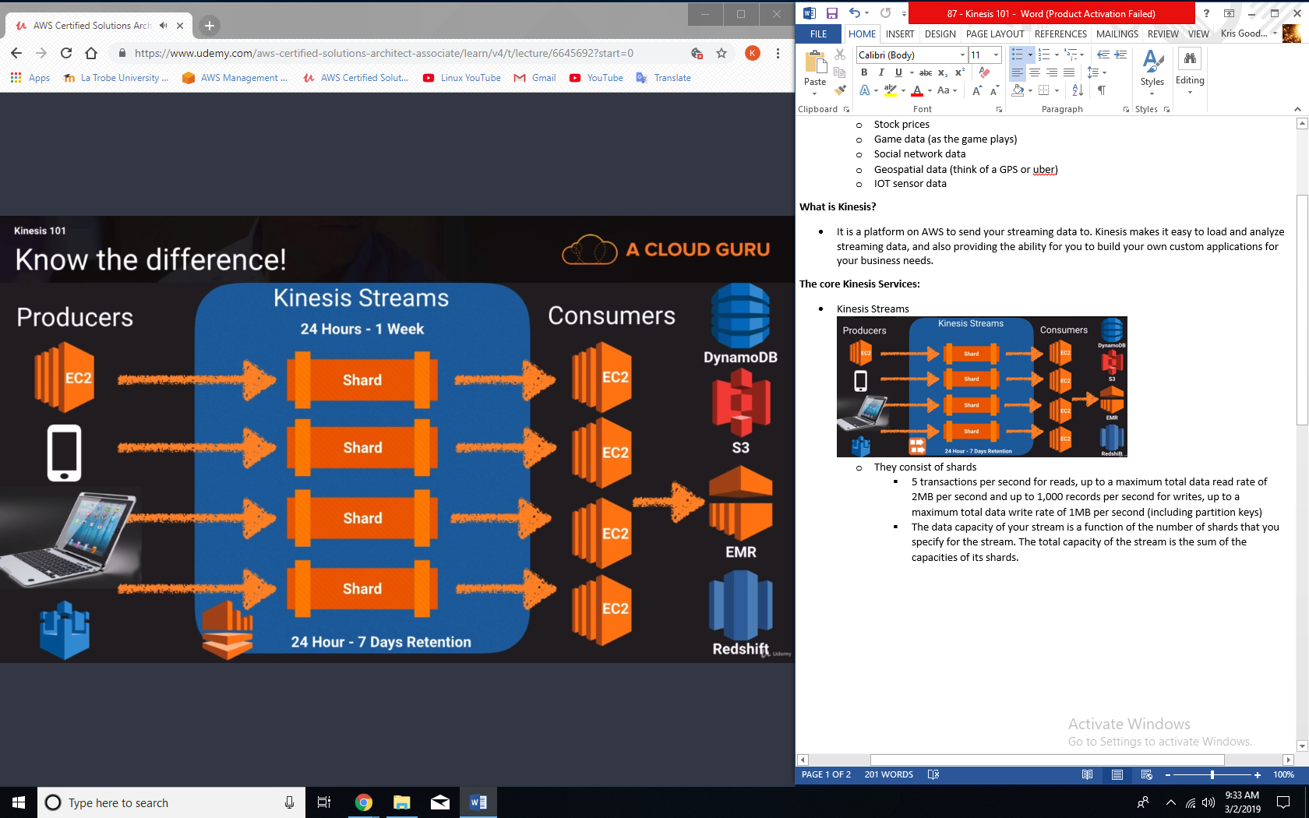
  + They consist of shards
    - 5 transactions per second for reads, up to a maximum total data read rate of 2MB per second and up to 1,000 records per second for writes, up to a maximum total data write rate of 1MB per second (including partition keys)
    - The data capacity of your stream is a function of the number of shards that you specify for the stream. The total capacity of the stream is the sum of the capacities of its shards.
* Kinesis Firehose  
  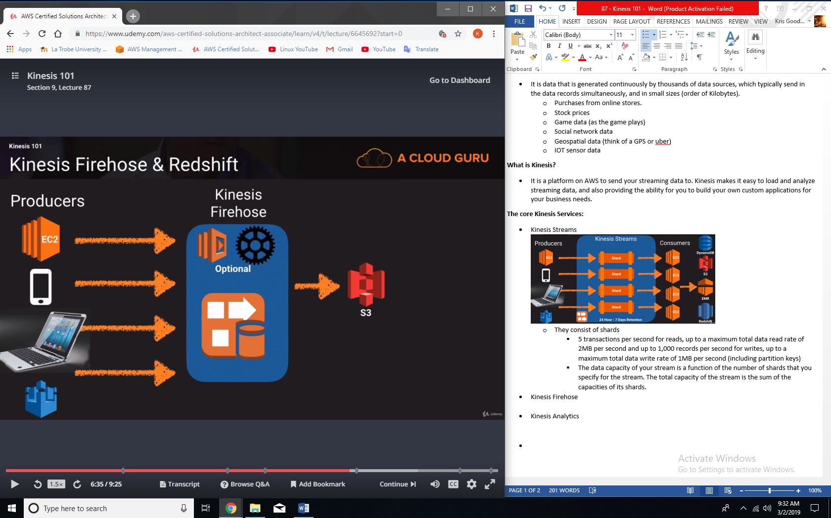
* Kinesis Analytics  
  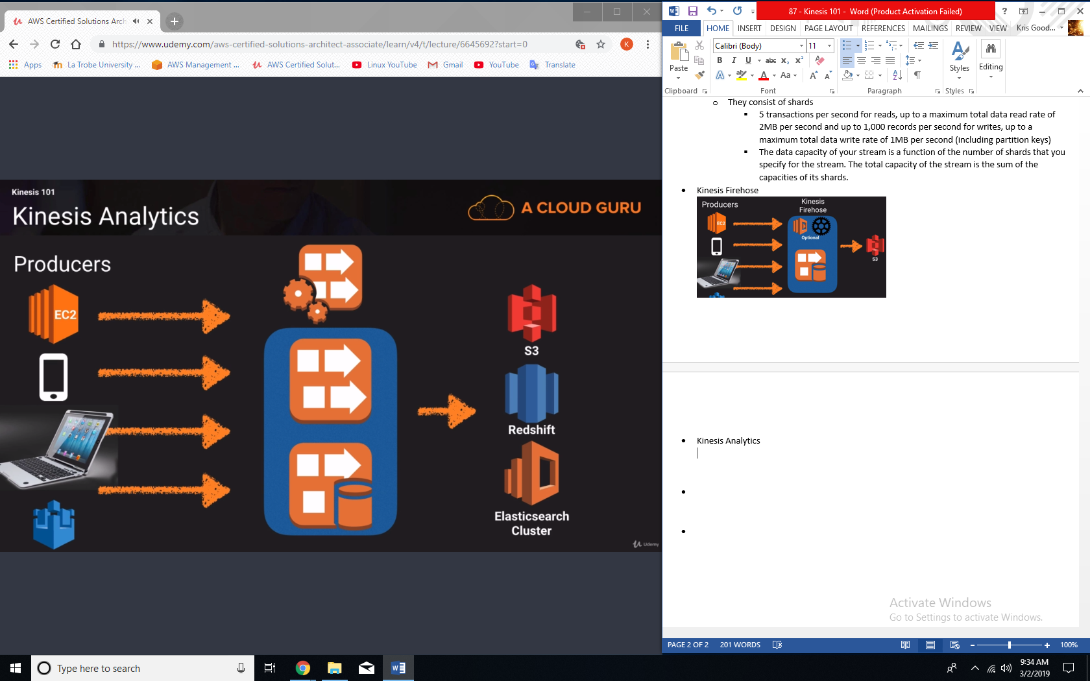

**Exam Tips:**

* Know the difference between Kinesis Streams and Kinesis Firehose. You will be given scenario questions and you must choose the most relevant service.
* If the question asks about shards then it is talking about streams because firehose doesn’t have shards, whereas if the question is talking about analytics then it is talking about firehose.
* Understand what Kinesis Analytics is.